EVATXK (cat)

"EVATXK" "red" 3

"EVATXK" "yellow" 7

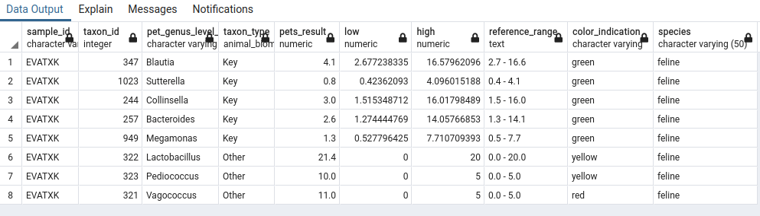

MTS Evaluation .

scenario 10

1)Moderate to Severe

Cats and dogs:

Any two of the following:

(High Red Flag Megamonas OR

High Red Flag Sutterella OR

High Red Flag Collinsella OR

Low Red Flag Bacteroides OR

Low Red Flag Blautia

);

OR Dogs: 8 or more yellow flags OR 8 or more red flags;

Cats: 11 or more yellow flags OR 9 or more red flags

Moderate to Severe Result : FFF

2)Mild to Moderate

Cats and dogs:

Any Two (High Yellow Flag Megamonas OR

High Yellow Flag Sutterella OR

High Yellow Flag Collinsella OR

Low Yellow Flag Bacteroides OR

Low Yellow Flag Blautia)

OR Dogs: 4-7 Yellow Flags OR 5-7 Red Flags;

Cats: 8-10 Yellow Flags OR 5-8 Red Flags

OR Cats and dogs: dietary recommendation of increase fiber or protein or decrease carbs (any of: low red flag Bacteroides, high red flag Fusobacteria, high red flag Collinsella, high red flag Sutterella, low red flag Fusobacteria, high red flag Prevotella)

Mild to Moderate Result :FFFF

Final Result : Balanced